RINGETTE RINGUETTE
CANADA
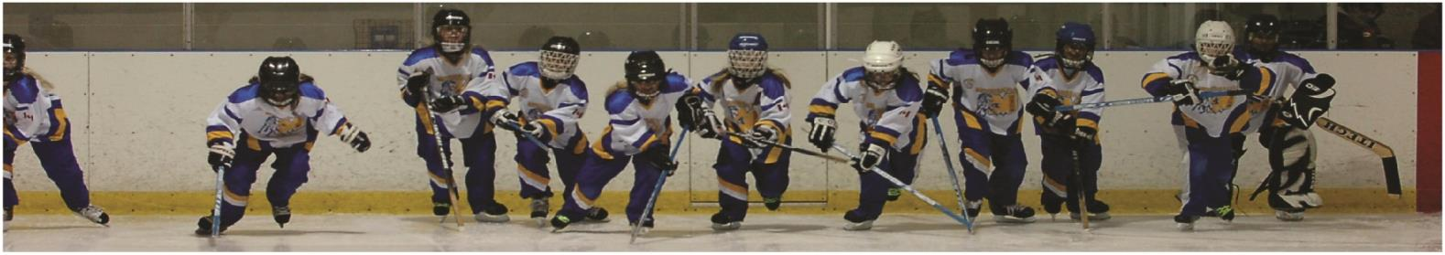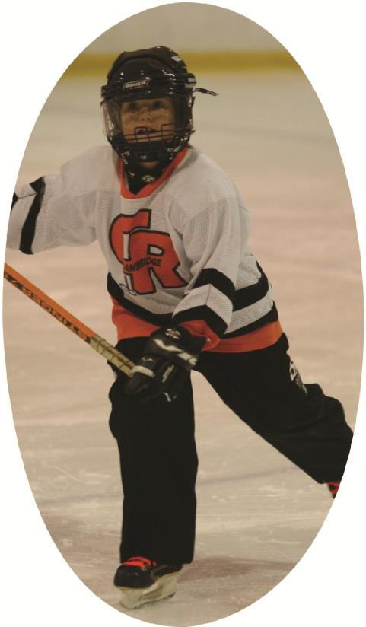
COMPETITION INTRODUCTION

PRE-COURSE TASK
COACH WORKBOOK

National Coaching
Certification Program

Ringette Canada @2023

CI Pre course Task Assignment
Introduction
Welcome to the Competition Introduction Course. The purpose of this pre-task assignment is to lay the foundation for Ringette Canada’s Competition Introduction workshop. The assignment helps ensure that you are adequately prepared to customize your learning and fully participate course content. You will need to complete and upload your pre- course excel workbook one week prior to the workshop.
Before you begin
• Download the Microsoft Excel Workbook to your computer, tablet or other device.
Rename (relabel) the Excel Workbook as CI Excel Workbook_Lastname, NCCP #, U Age Coaching. Example "CI Ringer 123456 U14") and save it. • Note: The workbook has been designed with instructions and tips to assist you in developing a plan that you can modify and continue along your life-long learning pathway and develop from season to season as a coach. Please try to familiarize yourself with the Excel document and how to use it.
The Competition Introduction Course will cover these topic areas:
1. Introduction to the NCCP and Ringette Canada Athlete Development Matrix
2. Planning a Ringette Season
3. Planning a Practice – Logistics and Structure
4. Planning a Practice – Designing Drills for Practice
5. Skill Development
6. Strategies and Tactics
7. Game Management, Scouting, and Statistics
8. Next steps and the Certification Process
Objectives
By the end of this pre-task assignment, you will:
- Develop a profile of your athletes to design a program that meets their age and stage of development.
- Set the groundwork to plan a Ringette Season appropriate to your athlete’s developmental stage (ADM)
- Identify activities to run a warmup and cool-down that develops athletic abilities
  - Prepare an Emergency Action Plan for your program
Pre-clinic task 1:
Knowing your Athletes, their Entry Point and our Program.
Open up the Starting Page tab on the Excel Workbook. Change the sample information to fill in your name and the rest of the logistics, including the first Monday and last Monday of your competition. Refer to the Athlete Development Matrix ADM) to determine the Athlete Development Stage of the majority of the athletes on your team (line 12)
Pre-clinic task 2:
Program Orientation and Ringette Canada’s Athlete Development Matrix
The purpose of this task is to gain an understanding on what should be prioritized in each ADM quadrant and what you should emphasize for your athletes age and stage.
- Differences
With what you know about the athletes on your team, choose either “yes” or “no” to indicate whether you think their differences in height, skill level, level of experience and or degree of social/emotional maturity will impact your planning.
- Major Orientations of your Plan
Review the Ringette Canada’s Athlete Development Matrix ADM) to get a general sense of the 5 components (Physical, Psychological, Life, Ethical and Technical/Tactical/Strategic), for the stage of your athletes.
- Train to Train (11-15 year olds) starts on p. 39.
- Train to Compete (15 to 18+ starts on page 56).
Use the information to guide your selection of the drop-down statement for General, Technical/Tactical/Strategic, Physical, Psychological, Life Skills, and Ethical Literacy skills that most closely reflects the focus of your training plan.
*Hint – you need to highlight the cell to the right of the title to see the arrow at the end to press for the drop-down menu

Pre-clinic task #3:
Training Objectives for Athletic Abilities
Open the Athletic Abilities tab. The Athletic Abilities (Physical and Motor) we use in ringette are listed in the left-hand column of the sheet.
We have listed their definitions in the “This Means Being Able to...” column. Complete the “Actions or Situations in Ringette that Require this Ability/Skill by sharing an example of where you might use that ability in ringette.
Pre-clinic task #4: Warm-up and Cool Down
In the Excel Worksheet/tab ‘Warm-up and Cool-down,’ add sample warm up and cool down exercises Your warm-up and cool-down pre- and post practice can support your plan.
Use pages 121 to 125 in the reference material and your own experience to add some sample activities that you could use to achieve the goals of a warm up or cool down.
General warm-up
- General exercises or games to raise body temperature
- Dynamic flexibility exercises
Specific warm-up
- Short activities that children already know and that mimic the movements of the main part
- Intensity should gradually increase but not tire the children Note: Never skip or rush a warm-up, as this may lead to injury.
Goalie warm up
- A proper warm-up should go encourage the goaltender to make routine saves using proper form. Start with low intensity shots and then increase the speed/accuracy of the shots as you progress through the warm-up.

Pre-clinic task #5: Emergency Action Plan (EAP)
Complete the Worksheets ‘EAP Contacts’ and begin filling out your teams ‘EAP’ for the facilities that you play and practice in. Your EAP will need to be completed for your CI Evaluation.
NEXT: Save and Submit your pre-clinic Excel Worksheet
Upload your CI Excel Worksheet to http://www.coachingringette.ca/c/ in your coaching portal
*Please bring the following items to the CI clinic:
- Your computer, tablet or other device with access to high-speed Internet.
- Download Adobe Connect (for online courses only)
- Ringette Canada NCCP Competitive Introduction Coach Workbook,
- Ringette Canada’s Athlete Development Matrix (hard copy of the section for your players or online access)
- A copy of your CI-Pre Task Assignment in your CI Excel Workbook
- Your competition calendar that has the following information:
- The number of practices you have per week (actual or approximate).
- The number of League games you have per week (actual or approximate)
- The number of tournaments and their dates, you plan to attend in the season.
- The number of dry land or other off ice training sessions you plan to have during the season.
- Event listing for team meetings, parent meeting, mental skill development sessions and other off ice sessions (approximate).
- The dates of your major competitions (playoffs, regionals, provincials, nationals)
*We will take you through how to complete the Yearly (Season) Training Plan
