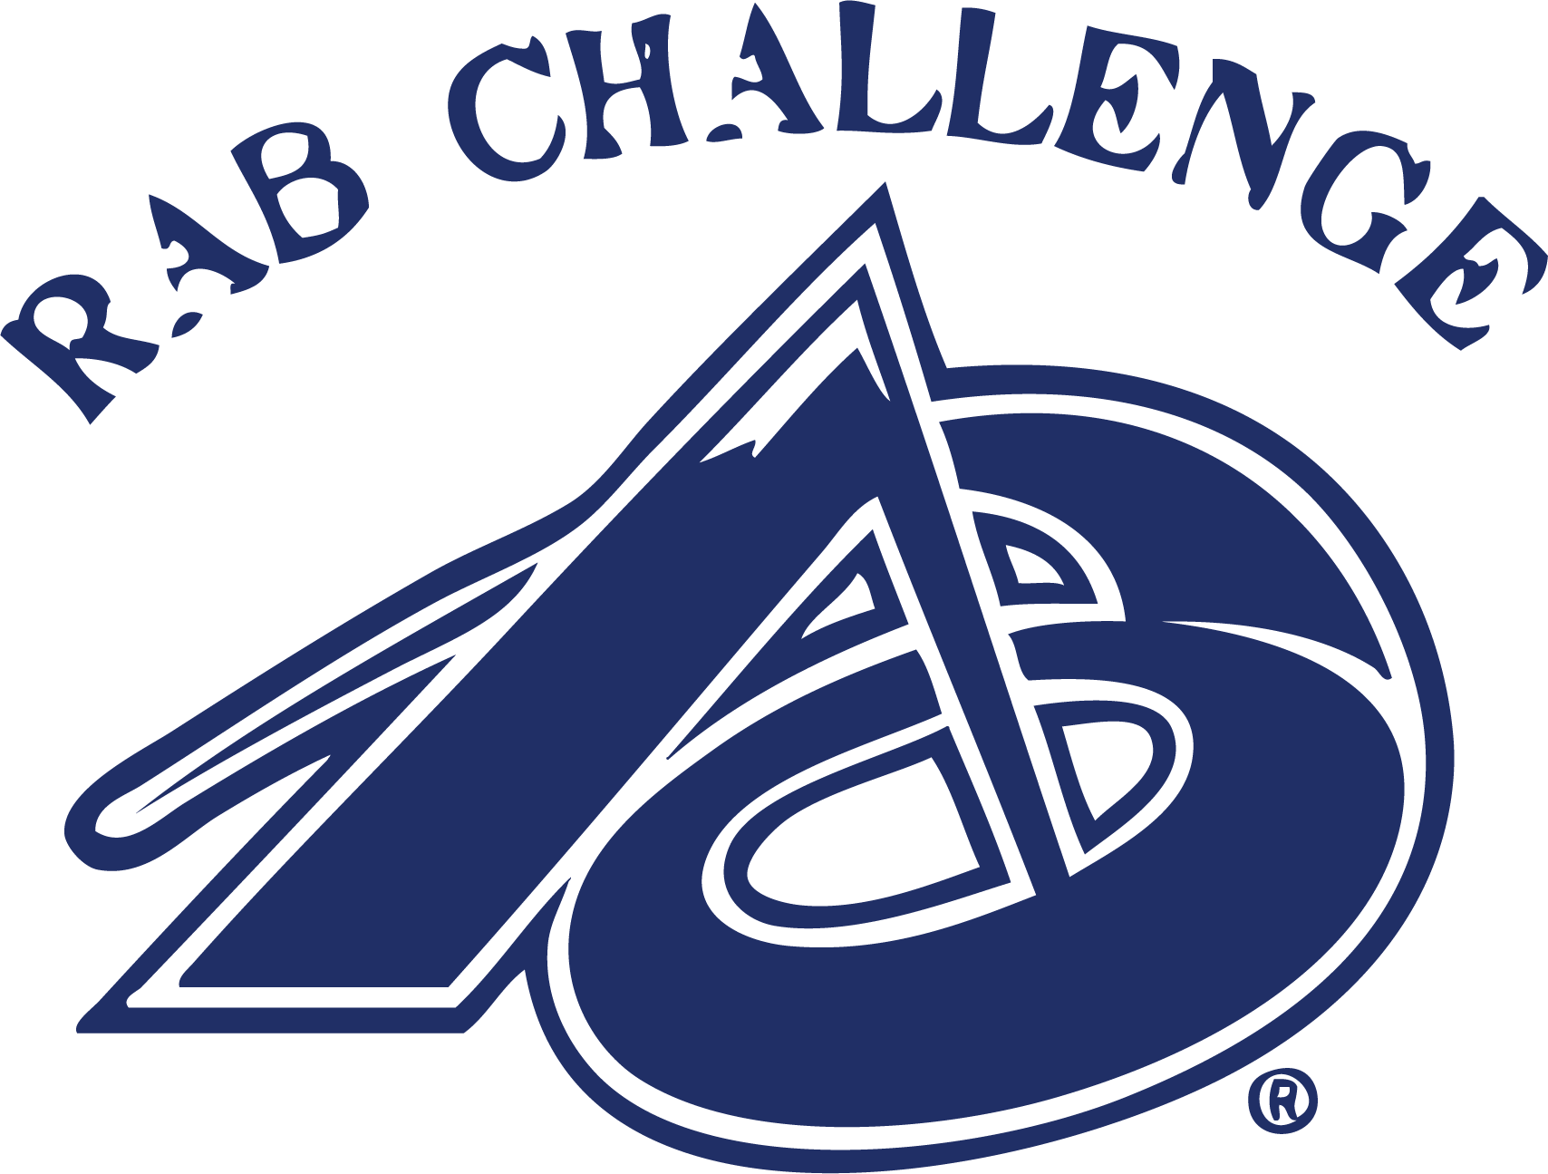

2023 Parent Package
April 14-16, 2023
St. Albert, AB

Thank you for registering for the annual RAB Challenge event hosted by Ringette Alberta.
Dates: April 14-16, 2022
Location: Servus Place
400 Campbell Rd, St. Albert, AB T8N 0R8

Our staff is very excited to get this event underway! This information package will go through key details for the weekend, including:
- On-Ice Events
- Off-Ice Events
- Spirit Points
- Swag
- Hotels
- Fees
- Minor Officials
- Teams/Schedules

This camp is an opportunity for athletes to participate on a team made up of athletes from across the province. Additionally, they will be exposed to new coaching styles in a fun, developmentally focused weekend. The goal of the weekend is to learn, meet new people and most importantly, have fun!
If you have any questions regarding the event, please contact:
Liz Brousseau
liz@ringettealberta.com

ON-ICE EVENTS
All athletes attending RAB Challenge will be guaranteed 5 ice times. All teams will have 2 practice/skills sessions and 3 games.

OFF-ICE EVENTS
Each team will also attend two off-ice sessions over the course of the weekend:
- Dare To Care: Bully Prevention Program
- Fitness for Pregame and Game Performance

In addition, each team will have a half hour Team Building sessions and “chalk talk” time with coaches so everyone can get to know each other and make some game plans.

RAB’S Got Talent Competition
On Saturday evening we will be hosting a RAB’s Got Talent competition. This event will have teams face off to show us their off-ice talents which could include a group dance routine, cheer, gymnastics, singing, magic show. We are ready to be “wowed” by our incredible young athletes' talents and imagination!
This event is not mandatory but will be a fun addition to the weekend. Please ask your child to come prepared with some of their favorite songs on their iPod or phone. The songs should be suitable to play in a public venue (non-explicit).
If there are gaps in your athlete’s schedule on Friday or Saturday, the team is encouraged to use this down time to practice their talent routine. Some time has been allotted to practice this, but you will likely need more time outside of that!
The winner of the air band competition will receive 25 spirit points, and the runner up will receive 15 spirit points.

SPIRIT POINTS
Over the course of the weekend, we are looking for athletes to get into the team spirit and show their team colours! Earn spirit points over the weekend by doing any of the following:
- Make a team banner (5 points)
- Teach your parents a cheer (10 points)
- Wear your team colours! (morph suits encouraged) (1 point per player/parent dressed up per day)
- Paint your face in your team colours (1 point per player/parent with face painted per day)
- Cheer on another team (10 points)
- BONUS: Creative ideas will be rewarded! Especially those with a sportsmanship or “Friends First” focus.

SWAG
Every athlete will receive a jersey as well as a t-shirt in their team colours. Please note that sizes given in registration were not guaranteed as the clothing was pre-ordered to ensure it arrived in time for the camp.

HOTELS
Ringette Alberta does not have a group block of hotels. Please make your own accommodations for the weekend.

LUNCH
There are three food venues on-site if you would like to send money with your child. Otherwise, please send a bagged lunch with a labelled water bottle to stay hydrated throughout the day.

FEES
All RAB Challenge athletes MUST have paid their registration fees before they will be allowed to participate in the event.

MINOR OFFICIALS
Each team should provide at least 2 minor officials for all games over the weekend. Minor officials will cover the following positions in the box:

- Shot Clock
- Time Clock
- Gamesheet
- Penalty Box doors

TEAMS/SCHEDULES
There is a team package which includes the team roster as well as the team schedule for the weekend. Please refer to these packages for all roster and schedule information.
Please note, many hours have been expended to ensure teams are even. We will not make any team changes to accommodate friend requests. All teams consist of athletes from around the Province, therefore most of the team will not know each other. This is a great opportunity for your child to step outside of their comfort zone and meet players they may compete against next year. Many friendships were formed at past RAB Challenges!
Teams were also created with an effort to distribute preferred positions, but some positions are over-subscribed. Coaches are instructed to give each athlete equal playing time and an opportunity to play any and all positions. This may require some athletes to play a game at a position they are less familiar with, presenting them with a low-stakes environment in which to learn something new!
Please check your schedule a few days prior to the event to ensure there are not any minor changes.
RAB CHALLENGE ON-ICE SCHEDULE
Please note, this schedule is only for on-ice activities. Final complete schedules for all teams are available on the website under the RAB CHALLENGE page.

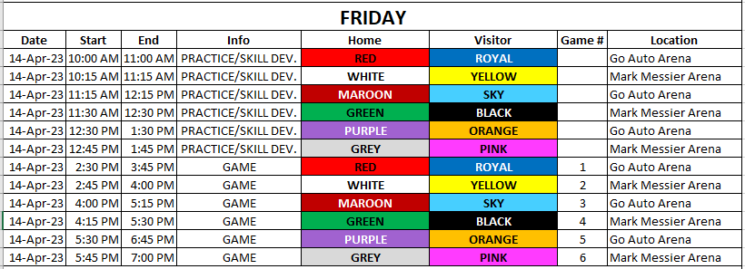
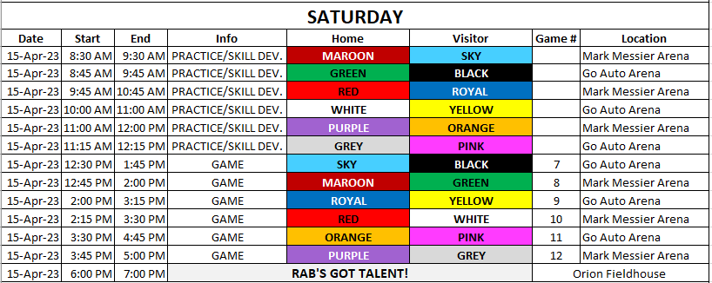

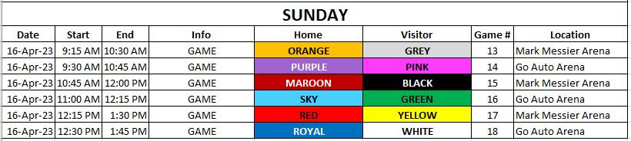

RAB CHALLENGE OFF-ICE SCHEDULE
