Athlete & coach emergency contact information & medical forms: see attached
Emergency #: 9-1-1 for all emergencies

Head coach: name & cell # for all, add more people as needed
Asst. coach(es):
Trainer:
Manager:

Charge Person
Charge person #1: name & cell #, these are people who are on the ice/bench
Charge person #2:
Charge person #3:

Charge person responsibilities:
- Clear the risk of further harm to the injured person by securing the area and shelter the injured person from the elements.
- Designate who is in charge of the other participants
- Protect yourself (wear gloves, etc.)
- Assess ABCs (checks the airway is clear, breathing is present, a pulse is present, and there is no major bleeding)
- Wait by the injured person until EMS arrives and the injured person is transported
- Fill in an accident claim form

Call Person
Call person #1: name & cell #, these are more likely people NOT on the ice, so a
Call person #2: parent/family member, recommend those who are most often
Call person #3: at the practices/games

Call person responsibilities:
- Call for emergency help
- Provide all necessary information to dispatch (facility location, nature of injury, what if any, first aid has been done)
- Clear any traffic from the entrance/access road before ambulance arrives
- Wait by the driveway entrance to the facility to direct the ambulance when it arrives (in most arenas this will be the Zamboni door)
- Call the emergency contact person listed on the injured person’s medical profile

Control Person
Control person #1: name & cell #, these are people who are on the ice/bench
Control person #2:
Control person #3:

Control person responsibilities:
- Secure a controlled environment
- Retrieve AED and/or first aid kit and bring to charge person
- Seek highly trained medical personnel in the facility if needed
- Ensure teammates, other participants, and spectators are not in the way
- Advise others of the steps being taken

Reminders:
- be prepared to offer your EAP to visiting teams
- record and report injury using accident report form
- this may include an insurance form that can accompany injured participant to the hospital
- make sure everyone knows their roles well ahead of time
- familiarize yourself with return to play protocols
- follow up with injured participant/family and provide updates to others as appropriate
- participant (athlete & coach) medical information is confidential, only use in an emergency
- it’s important to include coaches in this EAP

Most frequented arenas: [list ALL](see attached maps)
Kinsmen Arena 1979 111 St NW, Edmonton

Nearest hospitals: [list ALL]( (see attached maps)
University of Alberta 8440 112 St NW, Edmonton

ARENAS [list ALL]

Kinsmen Arena 1979 111 St NW, Edmonton
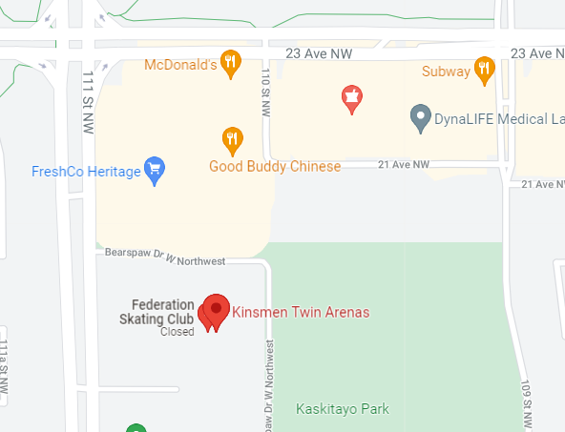

HOSPITALS [list ALL]

University of Alberta 8440 112 St NW, Edmonton
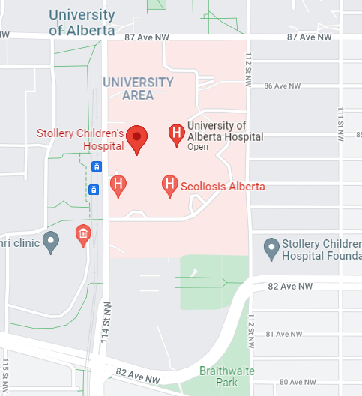

Sample emergency contact list:

*medical forms should be kept accessible but confidential unless absolutely necessary
**incident report forms & insurance forms should also be on hand to complete

Participant name | Emergency contact name | Emergency contact #
Ringette Alberta | Mom | Cell #
 | Grandpa | Cell #
Coach | Spouse | Cell #
 | Brother | Cell #

